Deployment Intructions

# 1. Index.

1. Index. 1

2. Target. 2

3. Database. 3

3.1. XAMPP. 3

3.2. Schneider database generation. 3

3.3. Connection configuration in the app. 4

4. User Manual. 5

4.1. Start server. 5

4.2. Execution. 5

# 2. Target.

The target of this document is to inform user how to deploy schneider devices manager.

# 3. Database.

First step of the deployment process is to prepare the database and the connection server.

## 3.1. XAMPP.

The software packet used is Xampp. This is a free software packet that will allow app to set a complete server easily.

Once the installation progress has finished, executing xampp control panel is needed. Control panel (Figure 1) allows user to start/stop apache server and MySQL services.

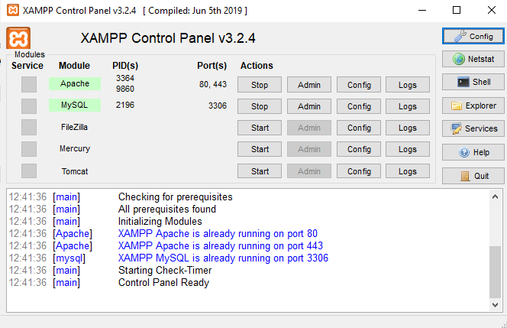

Figure 1: XAMPP Control Panel.

## 3.2. Schneider database generation.

After installing xampp, user has to import app database. In order to it, user will use database template provided in repository. To create app database, user has to open the manager by <http://localhost/phpmyadmin/>. Then, a database has to be created (preferably named “schneider_app” to simplify deployment progress) and import the file “schneider_app.sql” to generate the devices tables and dump initial data.

## 3.3. Connection configuration in the app.

Initially, app connection has a configuration with default values. In case that another parameters would be required, an code editor would be needed to modify main.c file, such as CodeBlocks.

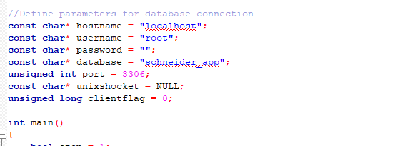

Figure 2. Default configuration.

Database connection parameters can be edited to satisfy user wishes, but this will required to include MySQL library and linker, and to compile the project again

# 4. User Manual.

Finally after preparing server and database, user computer is ready to execute Schneider devices manager.

## 4.1. To start server.

The first step is to start Apache and MySQL, by xampp control panel (Figure 1).

## 4.2. Execution.

To execute the manager, .exe file must be executed. This file is stored in the packet “bin.zip” of the repository and the folder “Release” contains the file “schneider_app.exe”. If user execute the file, a terminal with appear with the app interface.

## 4.3. Schneider devices manager inteface.

At the app opening, the main menú will be shown in the terminal, with 4 options that can be selected:

* Insert new device: allows user to insert a device in the database.
* Read devices table: allows user to show the whole table of a type of device.
* Search device: allows user to look for an specific device stored in the database.
* Exit: closes the app.

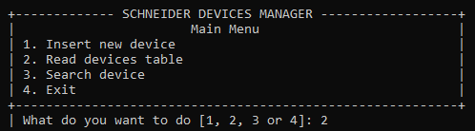

Figure 3. Main menu.

In each menu user will chose the devices he will work with, choosing between electric meter, water meter and gateway.

### 4.3.1. Insertion Menu.

The first menu is the insertion menu. In this menu, user can include a new device in the system. For this, it´s needed to include the following information:

* Serial Number, an unique numbre that identify the individual device.
* The brand of the device.
* The model of the device.
* IP (gateway only), the direction which device uses to be connected.
* Port (gateway only), the port which device uses to be connected by.

Note: There is an additional parameter automatically generated by the app for internal database management, the ID parameter.

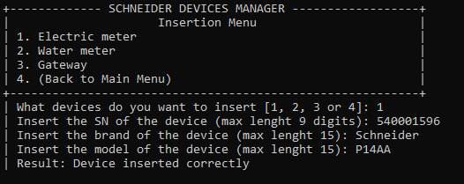

Figure 4. Insertion of an electric meter.

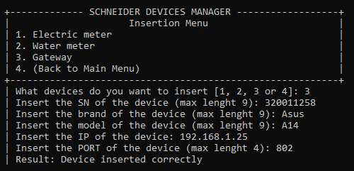

Figure 5. Insertion of a gateway.

### 4.3.2. List Menu.

The second menu is list menu. This option shows the whole table of the selected type of device.

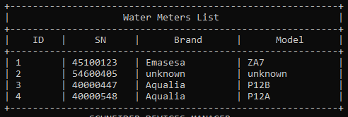

Figure 6. Water meters list.

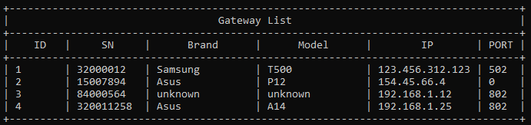

Figure 7. Gateway list.

4.3.3. Search Menu.

The third and last menu is search menu. In this option, app looks for a device in the database. With that purpose, user need to indicate the a searching key that app will use to perform the look for, which will be one of the parameters of the devices.

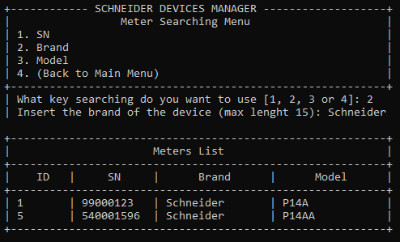

Figure 8. Result of Schneider electric meters request.